Simulation of MOSFET vs. Pentode Vacuum-Tube Band-Pass RF Filters

Daniel Ponsini, Theresa Pham, Haley Blanchard, Thomas Hudson

Department of Electrical and Computer Engineering, The College of New Jersey

(ponsind1, phamk2, blanchh1, hudsont2)@tcnj.edu

**ABSTRACT**

Throughout this paper, properties of the 6SG7 vacuum tube and MOSFETSs are compared and contrasted. Comparisons begin with the general properties of these components, such as their transfer curves, and are followed by a brief explanation of why JFETs are a suitable replacement for the resulting simulations. In these simulations, a portion of the RCA AR88 Receiver RF Amplifier (AR88 RF Bandpass Filter) was modeled in PSPICE. The simulation tested the circuit’s response to a sweep in frequencies (100kHz to 5000kHz). This was done initially by using the vacuum tubes in the original design and then repeated with the JFETs in their place to observe whether or not the output was similar. Both of these simulations behaved similarly to the range of frequencies used. The main difference was that the amplitude of the output voltage for the JFET simulation was larger than the amplitude of the vacuum tube simulation. This was expected due to known properties of these electrical components. This indicates the JFET and, therefore, MOSFETs in general, is an adequate substitute for a vacuum tube. This information can be used to improve circuitry.

**KEYWORDS:** Vacuum Tube, MOSFET, JFET, Band-pass Filter

# INTRODUCTION AND BACKGROUND

When looking at advanced FET design and application, the JFET is comparable to a MOSFET at room temperature. In this case, the 2N5458 JFET, another small signal, n-channel transistor, was used in place of a BS170 MOSFET. This substitution was valid because of the similar properties shared by the two components and would result in the same values and observations. As a result, it can be used in place of the BS170 for the simulations and observations. Most small signal transistors are interchangeable, causing only slight differences in the output, though one difference between these two particular transistors is that the BS170 works in enhancement mode while the 2N5458 works in depletion mode, as JFETs only function in depletion mode.

A MOSFET is a field effect transistor often used for amplifying electronic signals with the advantage that little current is needed to activate it while yielding a much larger current to a load. Like the JFET, the MOSFET acts like a voltage controlled resistor where the current flowing through the main channel between the drain and source terminals is proportional to the input voltage. MOSFETs and JFETs also both have very high input resistances that can easily accumulate large amounts of charge, though MOSFET input impedance tends to be much higher than that of JFETs. There are 4 terminals on a MOSFET, which are the drain, gate, source, and body/substrate, though the body terminal is normally not used, simply serving as a ground. N-channel MOSFETs such as the BS170 are widely used seeing as they are easy to manufacture and their power consumption is small [Electronics Tutorials].

For electronic components with more than two terminals such as transistors and vacuum tubes, which are being examined, the current-voltage relationship at one pair of terminals depends on the current and voltage of the third terminal. This means that there is a family of curves, which represent the current-voltage relationship [Van Der Bijl]. For most transistors and vacuum tubes though, the shape of the current-voltage relationship is the same. Figures 1 and 2 show the curves for the 2N5458 JFET and the BS170 MOSFET. The MOSFET output is much greater than that of the JFET, which may be due to the difference in the enhancement mode of the MOSFET versus the depletion mode of the JFET and the higher input impedance of the MOSFET. This difference was taken into account when substituting the MOSFET with the JFET.

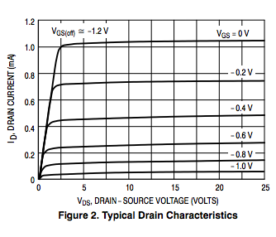

**Figure 1. 2N5458 JFET Current-Voltage Characteristics [Semi-Conductor Components Industries LLC]**

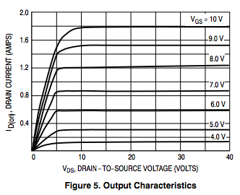

**Figure 2. BS170 MOSFET Current-Voltage Characteristics[Semi-Conductor Components Industries LLC]**

Figure 3 shows the current-voltage characteristics of an NPN-type bipolar junction transistor (BJT), another type of transistor and semiconductor, which actually replaced the vacuum tube over time. BJTs are current-controlled rather than voltage-controlled as MOSFETs and JFETs are, and its terminals are emitter, collector, and base rather than gate, source, and drain. While BJTs have replaced vacuum tubes over time, MOSFETs are more commonly used in digital and analog circuits, but it is clear that the shape of the BJT characteristics curve is still the same as that of the JFET and MOSFET curves.

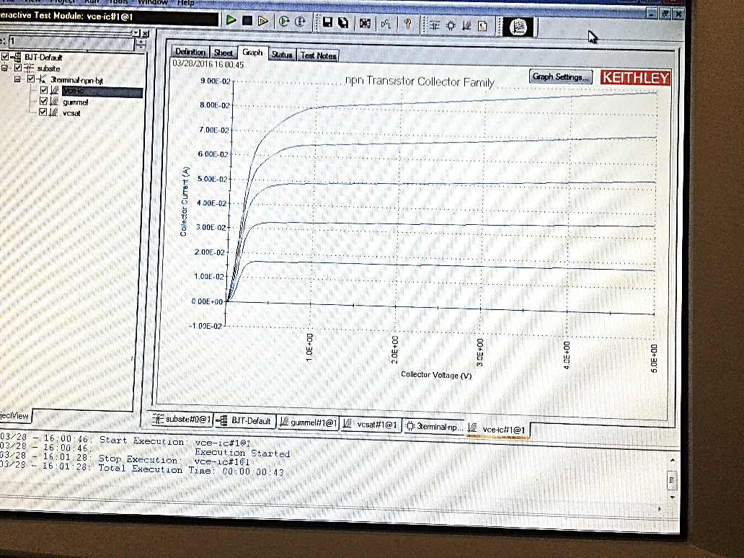

**Figure 3. NPN-type BJT Current-Voltage Characteristics**

A vacuum tube, invented in 1904, was a basic electronic component in circuits for a long time in the early 1900s before transistors were created, controlling current between electrodes. It was commonly used in the audio field, particularly for radio and musical instrument amplifiers. One type of vacuum tube is a pentode, which has five active elements. Figure 5 shows the current-voltage characteristic of a 6SG7 pentode vacuum tube, which again has the same shape as the BJT, MOSFET, and JFET curves, though its current output is lower than that of the BJT, it’s successor in electronic circuits.

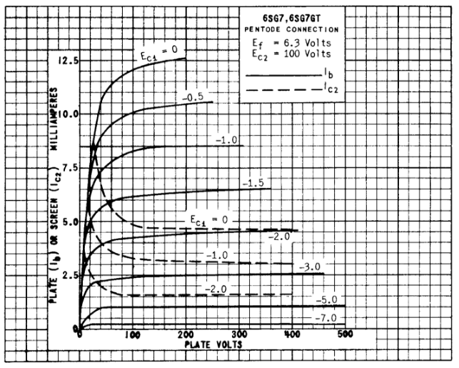

**Figure 4. 6SG7 Vacuum Tube Current-Voltage Characteristics**

The 6GS7 vacuum tube, NPN-type BJT, and BS170 MOSFET all have characteristic curves that are shaped the same. The BJT replaces the vacuum tube in modern times, but could a MOSFET replace a vacuum tube in a circuit as well? BJTs and MOSFETs, while having the same shaped curve for current-voltage characteristics, work very differently. MOSFETs are much more commonly used though and use less power than other components, as stated earlier.

# 2 DEVELOPMENT AND TESTING OF SIMULATION

The AR88 is a radio communications receiver that uses vacuum tubes to filter the signals to different desired bands. Using the AR88 schematic shown in Figure 5, a single band was isolated and used as the basis for the simulation. In order to test the properties of the vacuum tube and the FET, PSpice simulations were run using both parts.

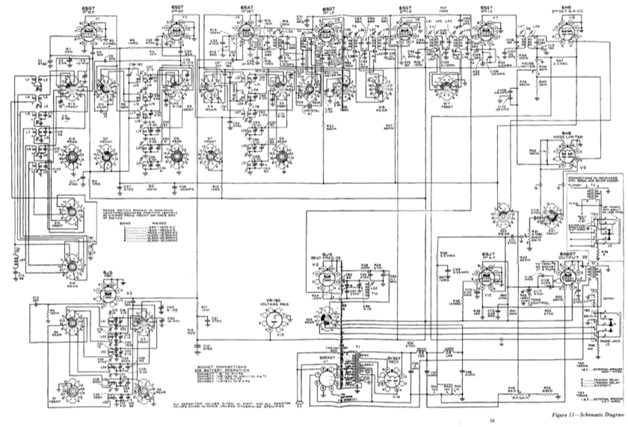

**Figure 5. AR88 Schematic**

Although the AR88 uses the 6SG7 vacuum tube, this model could not be found for PSpice. In its place, a similar vacuum tube model (the 6SJ7GT) was used. In order to test its behavior as a bandpass filter, an AC sweep of the frequency was performed. The band that was isolated, band 1 on the AR88, filters frequencies between 540-1600 kHz. In order to make sure that this band was included, the sweep was performed between 100-5000 kHz.

The first simulation was run using the vacuum tubes as shown in Figure 6. The output is measured after the last transformer (L24) and is shown in Figure 6. By changing the values of the inductors, different bands are allowed to pass through the filter. As seen in Figure 7, the band isolated falls within the desired band of 540-1600 kHz.

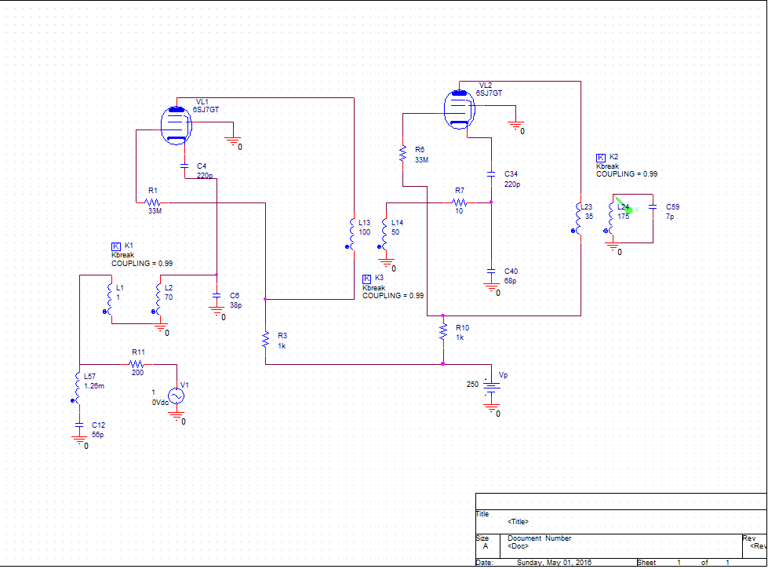

**Figure 6. PSpice Simulation using Vacuum Tubes**

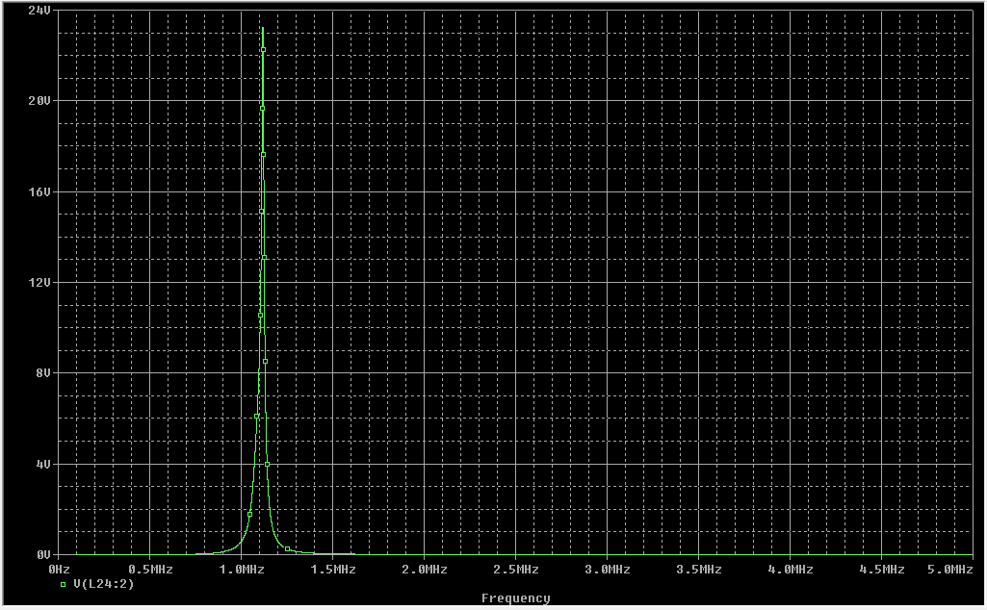

**Figure 7. Simulation Results from Vacuum Tubes**

In the second simulation, the vacuum tubes were replaced with the J2N5458 FET as shown in Figure 8. This was again simulated using the same simulation sweep as before in order to compare the two filters. As show in Figure 9, the same band was isolated. The only difference between the two filters was that this filter with the FET had a slightly higher amplitude.

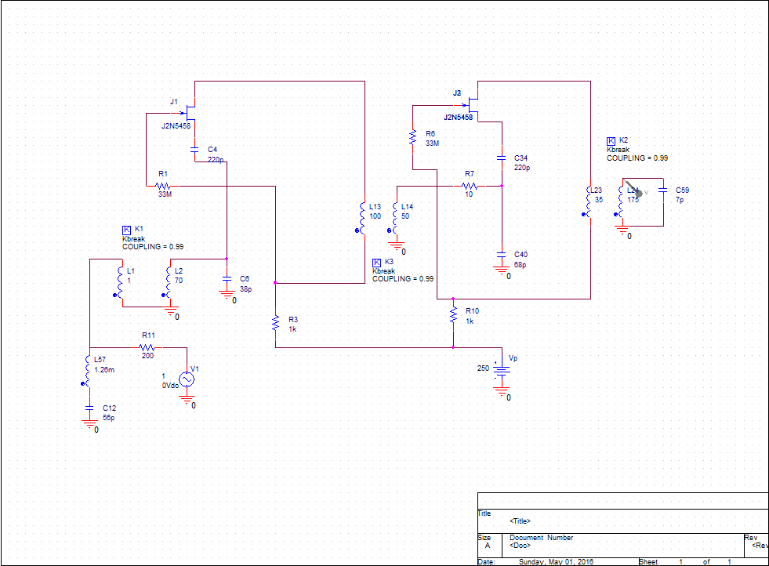

**Figure 8. PSpice Simulation using FETs**

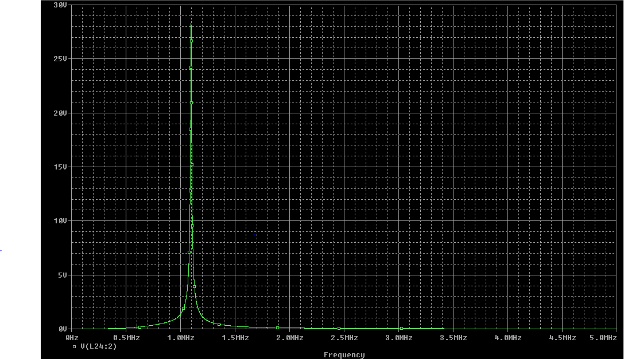

**Figure 9. Simulation Results from FETs**

# 3 CONCLUSIONS

With the finding that MOSFETs can be used in place of vacuum tubes and yield similar results, this information can be used in improving the circuitry of analog and digital circuits. As time goes on, people continue to look for faster, more energy efficient components for use in more elaborate and better functioning circuits. In fact the NASA Ames Research Center, are working on what they believe will be the next best thing in transistor technology: a vacuum-channel transistor. This transistor combines the old vacuum tube technology with the modern semiconductor-fabrication techniques, taking the best aspects of both to make a small and cheap device. It takes away the drawbacks of the vacuum tube’s size and cost, and gets rid of the electric filament/hot cathode to reduce power consumption. Figure 10 shows a diagram of how this new transistor will look in comparison to the MOSFET.

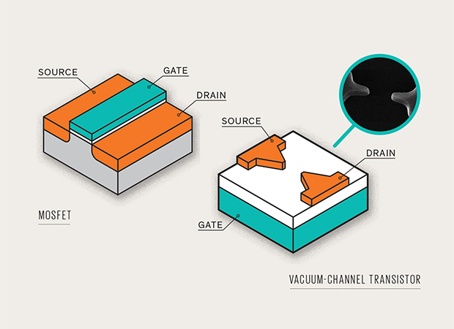

**Figure 10. Vacuum-Channel Transistor [Provost]**

This research is still in its early stages, but if it is eventually able to function as it is intended to, it could have a huge influence on the electronics industry, and it will show how vacuum tubes are not yet irrelevant in the world of circuitry.

# REFERENCES

BS170G Small Signal MOSFET 500 MA, 60 Volts (2011): 1-4. Semiconductor Components Industries, LLC. 2011.

"Difference Between BJT and MOSFET." Difference Between. N.p., 24 Feb. 2010. Web.

"JFET's - General Purpose." (2010): n. pag. Semiconductor Components Industries, LLC. 2010.

"JFET and MOSFET Comparison." Electronic Circuits and Diagram Electronics Projects and Design. N.p., n.d. Web.

Provost, James, Meyya Meyyappan and Jin-Woo Han. "Introducing the Vacuum Transistor: A Device Made of Nothing." - IEEE Spectrum. N.p., 23 June 2014.

Van Der Bijl, H. J. "Thoery and Operating Characteristics of the Thermionic Amplifier" Proceedings of the IRE, Vol. 7. Google Books. N.p., n.d. Web.

"The MOSFET - Metal Oxide FET." Electronics Tutorials. N.p., n.d. Web.